

E-mail: president@strawberryfarms.org
Website: www.strawberryfarms.org
Facebook: Strawberry Farms
Mail: PO Box 1251, Westerville, OH 43086-7251

Strawberry Farms Civic Association
THE CIVIC CHATTER
Fall 2014 Issue

SFCA 2014 BOARD MEMBERS
President: Tina Morris
tinamz54@gmail.com

Treasurer and Membership Director: Anita Absalom
treasurer@strawberryfarms.org

Dir. Neighborhood Safety
Theresa VanDavis
sfblockwatch@hotmail.com

Dir. Landscaping: Patty Fitzgerald
pjfitz3@wowway.com

Dir. Social Activities:
Stephanie Flowers
Newsletter Editor & Webmaster: Alice Hohl
alice@siteinsightnow.com

Secretary & Director of Newsletter Distribution:
Mike Hillberry

Dir. of Advertising: Tim Madrid
timothymadrid@gmail.com

Looking for Volunteers:
We are always looking for additional residents to fill out the board and help work on committees and projects!
Elections are Oct. 28th, so email the President if you are interested in running for a position!

4th Annual Fall Festival!!
Sunday, Sept. 28nd, 2-4pm
Where: 5300 Strawberry Farms Blvd. EMA Bldg.
- Petting Zoo and Pony Rides
- Face Painting
- Crafts for kids
- Snakes will make their appearance! (weather permitting)
- Police Cruiser
- Fire Truck
- Food
- A few new surprises!

Brief Update on Church Property:
The church at 161 and Strawberry Farms Blvd. is slated to be torn down and replaced by upscale apartments due to the church needing to sell the property.
The closing date is expected to be Sept. 12 (as of this writing) and work is expected to begin in mid-October.
The developers have designated a liaison to communicate with the Civic Association during the process.
Congratulations to our Beautification Award Winners!

First Prize:
Benjamin and Arleen Everhart, 3865 Wintergreen Blvd

Four Honorable Mention Awards:
Tim and Rise Gordon 5323 Bittersweet Court
Jim and Cathy Pennington 5329 Bittersweet Court
Jack Trott 3782 Harborough Drive
Linda Pierce 3630 Watt Road

The Board of Directors for Strawberry Farms Civic Association wants to thank these winners for all their hard work in beautifying our community. It was a hard decision since there were a lot of other properties that were in the running. They are all assets to the SFCA community.

Brief Update on Church Property
The church at the corner of 161 and Strawberry Farms Blvd. is slated to be torn down and replaced with upscale apartments. Please refer to the Civic Association website or previous newsletters for the history of this development.
Although the zoning changes are complete, the sale of the property is not, as of this publication.

A special thanks to Mike Liston & Ron Christiansen for mowing & maintaining the Watt Rd. entrance!!! Mike has been doing this for years! Thanks!!!!!!!





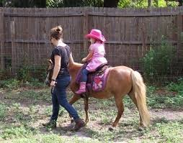
Membership is $15 & members get 20 tickets free! Tickets are $1 each
Pony ride = 2 tickets
Face Painting = 1 ticket
Hot dog, chips, bottles water = 1 ticket each or all 3 for 2 tickets
Raffle = 1 ticket
The rest is free! Bring friends for a great time!

Page 2
The Civic Chatter

Park Improvements Coming!

Our beloved Strawberry Farms Park is going to get a facelift!
(To see a larger image, visit www.strawberryfarms.org)
Here are some of the improvements we will be seeing as a result of new investment by the City of Columbus Recreation and Parks Department (which is occurring at the same time we are seeing a designation of the park fee from the developers of the church property for improvements at the park):
- Ramp for bikes, wheelchairs, strollers to replace curb at the street entrance to the park on Marden Court. For those who ride their bikes on the bike path, this means you can enter the park at the end of the court directly, rather than riding over the grass or stopping to pick your bike up over the curb.
- New shade trees and a half-court basketball court at the entrance to the park from Marden Court. (This is the location where the large Port-a-John is located now.) There is existing safety lighting in this area.
- Replacement of landscape timber steps leading into the park from Honeysuckle Blvd., and repair to the path at the base of the stairs in the same location.
- At the picnic shelter, the enclosed portion of the shelter, which is no longer used for storage, will be removed to expose the shelter to view, which should improve safety.
- A permanent Port-a-John concrete pad and wooden screening around three sides of the Port-a-John will be installed near the picnic shelter. This is to minimize vandalism and tipping over the Port-a-John, as well as making it more visually appealing. (The Parks Department was unable to install permanent bathrooms with running water.)
- New preschool/tot play area, across the path from the large play structure intended for older children.

- New shade trees along the back of the swing set and tot play structure.
- One new picnic table closer to the path and accessible by those using a wheelchair
- Repairs to the chain link fence/backstop at the end of the field
- Additional benches along the path
- Pavement markings to lead cyclists and runners around the bridge side of the path to keep traffic low near the play structures.
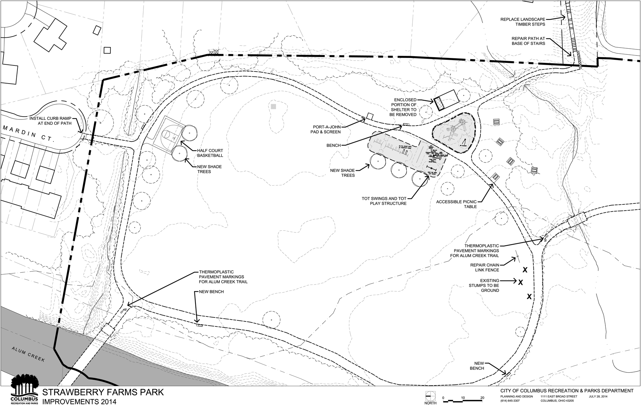

Did You Know…
…You can ride the bike path from Strawberry Farms south to Easton and north through Westerville all the way to the Village of Sunbury!
…A connection is being built now to extend the path below Easton Fields to connect with the southern section that goes all the way to Pickerington!

Safety in Strawberry Farms
1) Please sign up to participate in Walking Patrols around our neighborhood. Sign up and find out more at http://www.strawberryfarms.org/patrol.
2) Please report crime to the police when you see it. It's great that people are sharing concerns on Facebook, but it's also important to contact the police so that our neighborhood will receive the attention it deserves from the Columbus Police Department.

2014 Saturday Landscape Clean-Up Dates
(Every 3rd Saturday, March-November)

We begin at the 161 entrance at 10am but you can come anytime, or even any day to help pull weeds! ☺

September 20st
October 18th
November 15th





Membership Counts!
By: Anita Absalom, Director of Membership
The Civic Chatter
Page 3
It’s that time again! The Strawberry Farms Civic Association is beginning its annual membership drive and we need your help! Strawberry Farms is a large community (with over 900 houses!). If just half of the homeowners joined the association, we would have nearly 10 times the membership and resources that we have now! Your participation is vital to our association to maintain and improve our neighborhood and make it a safer place to live!
Not sure if you are paid up? Email Anita at amabsalom@yahoo.com. Then register online with a repeating payment so you never have to worry again!
For a mere $1.25 a month ($15.00 annually) you and your family can become members of the Strawberry Farms Civic Association. All members of the 2014 association (new and renewal members) will be entered into a drawing for a $100 Visa gift card! The drawing will be held at the end of the year.
Please complete the membership form below TODAY and mail to:
SFCA PO Box 1251, Westerville, OH 43086-7251
OR
Register and pay online: http://www.strawberryfarms.org/online-membership-application/

Thank you for your participation and for being a valued neighbor of our community!
------------------------------------------------------------------------------------------------------------------------------------------------
 STRAWBERRY FARMS CIVIC ASSOCIATION MEMBERSHIP
2014 Membership Year
(January 1 – December 31)

Please check one: _____Renewal _____New Member ____ Newsletter only Paid by: ___Check ___Cash
Annual fee is only $15. That is a mere $1.25 per month to be part of maintaining and improving our neighborhood!
So please join us!!

Name:

Spouse/Other:

Street Address:

Phone:

Email:
Email address is REQUIRED for Newsletter Distribution and for SFCA communication only.

Please make your check payable to SFCA & mail to: SFCA PO Box 1251, Westerville, OH 43086-7251

Interested in Volunteering?
___Block Watch (All Strawberry Farms homeowners are automatically a member of the
Blockwatch Committee!)
___Adopt a Speed Treatment
___Landscaping—weeding, mulching, mowing, etc.
___Donate Landscaping Materials
___Board Member
___Social Activities
___Other donations of choice:


The Civic Chatter
Page 4
Strawberry Farms Garage Sale Sept. 20th

Join us for our community garage sale on Saturday, Sept. 20! (Sept. 21 is the rain date.) Host your own garage sale at your house, and benefit from the increased traffic when your neighbors have their garage sale the same day!
The Civic Association sponsors a newspaper ad to help promote all the neighborhood garage sales!
Put a balloon on your mailbox!

The Civic Chatter

City Contact Numbers
Police…………………….645-4545 Fire……………………….221-2345
Water Service…………..645-7788 Sewer/Drains…………...645-7102
Electricity………………..645-7627 Loose animals…………462-3400
Bulk pick-up……………645-8774 Weeds/Environment…..645-9139
Code enforcement…….645-8139 Parking violations……..645-6400
Junk cars/private………645-8139 Junk cars/public……….645-2277
Mayor’s action line…….645-2489 or 311
SFCA Liaison/Dick Graham………645-7371 regraham@columbus.gov



Please welcome these new members to SFCA!
Thanks to all the faithful renewing members as well! You really do make a difference!!!!

Advertise!
Please support our advertisers
who so generously support the
newsletter.

It's inexpensive and effective to advertise with Strawberry Farms! Your ad will be hand-distributed in our newsletter to the 900+ homes in our community. Also you can choose to be featured in an ad on our website! Ads start at just $15! Contact Tim Madrid or go to our website at StrawberryFarms.org.



If you haven’t joined please consider doing so now!
It’s never too late!

Barbara & Michael Allen
Joe Belger
Carl & Janice Bloomfield
Dan Brookman & Rachel Pennypacker
Cheryl & John DoBroka
Sarah & Shawn Fritz
Ben & Beth Hallauer
Shirley Havener
Maureen Henry & Chris Keck
Mike & Jessica Hillberry
Todd & Toni Jester
James Jones
Jonathan Koo & Melodie Stevens-Koo
Jamal Nassir & Hassan Fachtab
Eugene & Lisa Pelino
Barbara Pitro
Bill Reinhart
Christa & John Sims
Erin Tierney
Kimberly & David Troutner
Katie Waltz
Kristie Waltz
Amy Webster


RE/MAX
Achievers

Cricket Such 614-848-9400 x249

CRS, ABR 1-800-688-7320

Licensed since 1974 RMXbug@aol.com

RE/MAX Hall of Fame


The Civic Chatter was printed for the SFCA at a generous discount by your neighbor, Bill Reinhart!

Remember Bill for all your printing needs!

The Reinhart Printing Co.
614-268-0181
Email:
reinhartprtgco@aol.com

A special thanks to Real Estates Signs & Services
owned by
John & Carolyn Hertlein!

They have supplied our signs at a great discount & sometimes as a donation!


